Classwork 5/5/2025
Read the paragraph about the Ndebele nation and answer the questions.
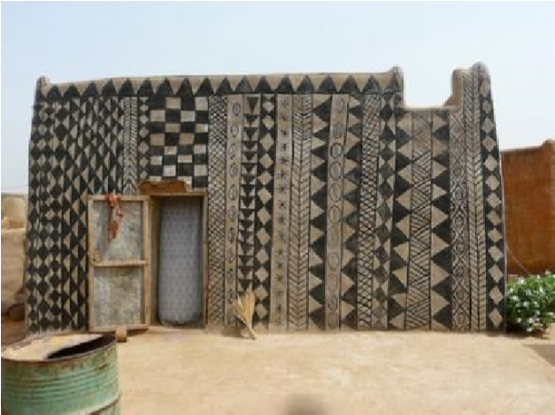 | 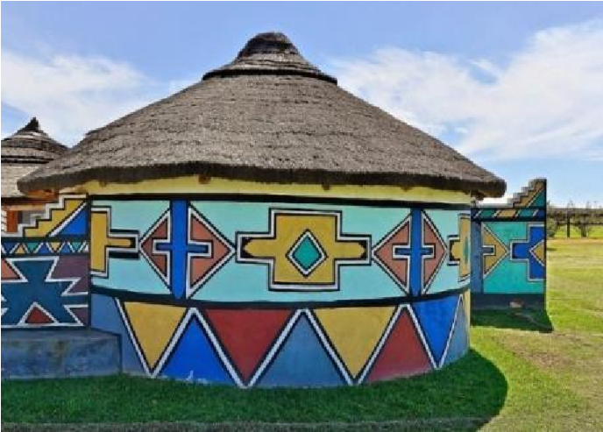
Figure 1 | Figure 2

Living in South Africa and Zimbabwe, the Ndebele Nation is an ethnic group that is known for its incredible artistic talent. Using their homes as canvas and studios, the women of this ethnic group create beautiful works of art that have been passed down from generation to generation. Not only do they paint their houses in a unique style, but they also use their homes as studio spaces. At home, they create wearable beadwork like headgear, bracelets, and necklaces. Even though the tribe is shrouded in mystery, their artwork is adored by the world.
1. What is the Ndebele nation known for?

- Can you identify any shapes used in fig no 2?

- What other art pieces are they creating? Name three. (3)

- Do you think their houses are painted in a unique style? Give a reason for your answer.

Principles of design.
- Emphasis: Does this drawing have a vocal point? Mark the vocal point with an “X” on the drawing.
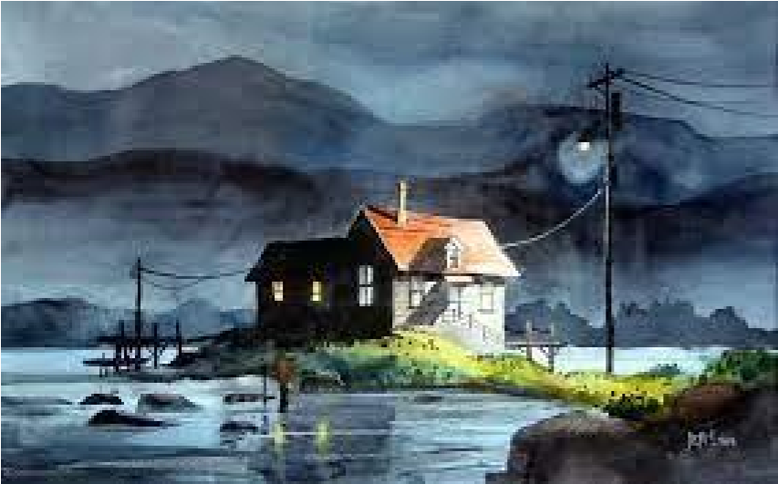
The object in the middle is the focal point.

- Contrast: Look at the drawing below. Did the artist make use of contrast?
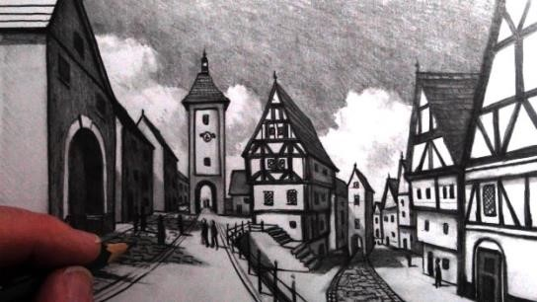

- The Ndebele nation is known for their unique houses decorated with repeating patterns and colourful paints. Create your own patterns on the house below.
Make use of lines and shapes.

