Creative arts: Classwork 25/02/2025

- Underline the correct answer in each sentence.

1.1 Tone refer to the degree of (light and dark / shapes)
1.2 A painting is an example of (2D / 3D) art.
1.3 A sculpture is an example of (2D / 3D) art.
1.4 Decorative or practical objects made by hand is called (craftwork / drawings)
1.5 (Tone/texture) in art refers to how light or dark a color is.
1.6 A (collage/painting) is an artwork that is made up of pieces of paper, photographs, fabric stuck onto a surface.
- Find the principles of design below and circle them.
pattern | contrast | balance | emphasis

b | a | l | a | n | c | e | c | d | t | w
b | c | d | k | p | o | t | v | x | c | a
c | q | w | v | e | n | c | o | p | x | s
l | z | a | u | z | t | p | m | e | z | d
b | e | r | p | a | r | z | n | j | k | g
v | x | u | u | p | a | t | t | e | r | n
e | m | p | h | a | s | i | s | x | w | g
c | s | w | m | p | t | y | v | z | o | u

  - Identify the element of art in each picture.
line | shape | texture

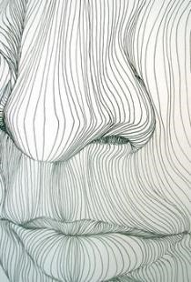 |  | 