Creative arts: Grade 7
Classwork 18/02/2025

- Shape is an element of Art. How many of these shapes can you identify? Write down in the space provided.
Star | triangle | square | rectangle | Heart | circle

Shapes
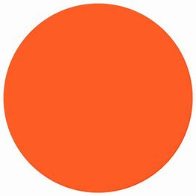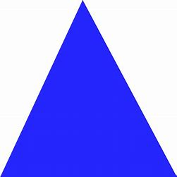

------------------------- ---------------------------- ----------------------------------------


------------------------- -------------------------- ---------------------------------

- Name the 3 primary colours.
------------------------------------------------------------------------------------------------------------------------------------------------------------------------------------------------------------------------------------------------------------------------------------------------------------------------------------------------Texture can be smooth, rough, hard or soft. What will be the texture of the following objects? Write down in the column. (Hard/soft/rough/smooth)
A blanket
A brick
A t-shirt
The skin of an elephant

